Bank management system

Proposal

**TO: MAM SADAFD**

**FROM:**  JAHANZEB NAWA-22

UMER QURESHI-18

MUHAMMAD JAWAD-13

SAMAN-20

**BANK MANAGEMENT SYSTEM**

**INTRODUCTION**

**“**A bank is a financial institution and a financial intermediary that accepts deposit and channels those deposits into lending activities, either directly or through capital market. A bank connects customers with capital deficits to customers with capital surpluses.”

**OBJECTIVES**

The application will be extremely beneficial for the customers intending to use and operate their bank account and will get various benefits in the field of management of accounts on a clear and user-friendly platform.

Bank account system is a simple application, which is especially generated and designed for the bank in order to enter the applicant information about his or her bank account and can perform other function like currency change. It is user name and id protected as well.

**Following are the major objectives behind the new proposed system:**

* It creates a user friendly environment, where a normal user can access through all the benefits of the system.
* It provides security from unauthorized access, only admin or authorized users are access granted to the system.
* It increases efficiency and save the time.
* No any danger and obstacles from external entities.
* Easy access or saved data inside the system.
* Complex banking operations and transaction operations are efficiently handled by the application.
* It is cost effective.
* It has ease of use along with complete reference.
* It is highly secured and less time consuming; hence time wastage can be avoided.
* Up to date record of the customers are maintained by the authority.

**THE EXISTING SYSTEM:**

The system will check the user’s existence in the database and provide the set of services with respect to the role of the user. The application is based on three-tier architecture. The cipher key obtained will help to find the fraud application. The business logic helps in authenticating the application, authorizing the users and providing services. The technologies are chosen by keeping the compatibility and performance as the constraints for the application**.**

## Further Drawbacks of the Existing System:

The following are the drawbacks of the existing manual System.

**Time Delay:** In the existing system, information related to all transactions is stored in different registers. Since all the transactions are stored in different registers it takes lot of time to prepare different reports.

**Redundancy:** As the information passes through different registers, each register is consolidated and sent to next register. So the same information is being tabulated at each register, which involves lot of complication and duplication in work, thus it causes redundancy.

**Accuracy:** Since the same data is compiled at different sections, the possibility of tabulating data wrongly increases. Also if the data is more, validations become difficult. This may result in loss of accuracy of data.

**Information Retrieval:** As the information is stored in the particular Format, it can only be retrieved in the same format. But if it is to be retrieve in different format, it is not possible.

**Storage Media:** In the existing system, data transaction being stored on too long registers it is very difficult to refer after some time.

**Reports:** At the various reports are tabulated manually. They are not such

Attractive and require more time. They do not provide adequate help in maintaining the accounts.

**Enquiry:** Enquiry for different level of information is much more difficult. On

Line enquiry of data is not possible.

**PROPOSED SYSTEM**

System analysis will be performed to determine if it is feasible to design information based on policies and plans of the organization and on user requirements and to eliminate the weaknesses of the present system.

General requirements are: -

1. The new system should be cost effective.
2. To augment management, improve productivity and services.
3. To enhance User/System interface.
4. To improve information qualify and usability.
5. To upgrade system’s reliability, availability, flexibility and growth potential.

## Developers Responsibilities Overview:

The developer is responsible for:

1) Developing the system, which meets the SRS and solving all the requirements of the system?

2) Demonstrating the system and installing the system at client's location after the acceptance testing is successful.

3) Submitting the required user manual describing the system interfaces to work on it and also the documents of the system.

4) Conducting any user training that might be needed for using the system.

5) Maintaining the system for a period of one year after installation

**DESCRIPTION ABOUT ATTRIBUTES AND ANTITIES**

The bank management system is an application for maintain a person’s account in a bank. The system provides the access to the customer to create an account, deposit/withdraw the cash from his account, also to convert currency. The following documentation provides the specification of the system.

We are mainly concerned with developing a banking system where a customer can submit her/his deposit amount to bank if she/he has an account or can create a new account in this bank. Customer can also view the status and change currency of his/her bank account, can view account balance. One can easily maintain the above things if he/she has an account by login through his unique account number.

**MODULE DESCRIPTION**

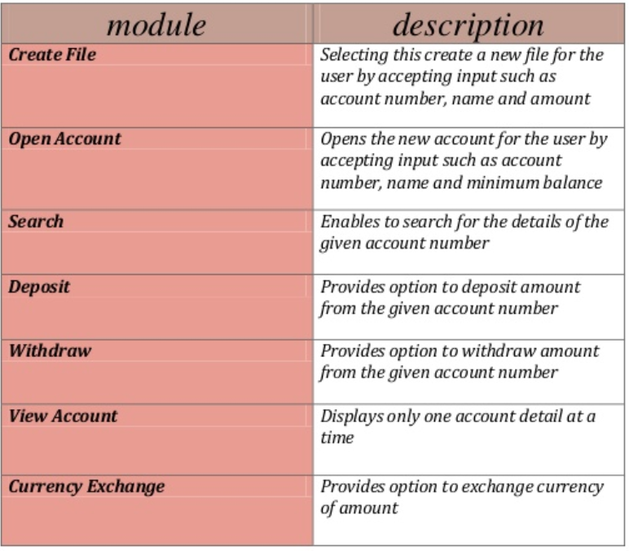

**ERD DIAGRAM**

Entity-Relationship Diagram is a graphical representation of entities and their relationship to each other. It describes how data is related to each other. An entity is a piece of data an object or a concept about which data is stored. A relationship is how the data is shared between entities. In E-R Diagram, there are 3 main components:

# C:\Users\Ali\Desktop\hospital-management-system-project-17-638.jpg

# Use Case Diagrams

A use case is a set of scenarios that describing an interaction between a user and a system.  A use case diagram displays the relationship among actors and use cases.  The two main components of a use case diagram are use cases and actors.

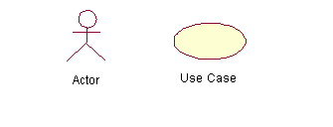

An actor is represents a user or another system that will interact with the system you are modeling.  A use case is an external view of the system that represents some action the user might perform in order to complete a task.

### When to Use: Use Cases Diagrams

Use cases are used in almost every project.  The are helpful in exposing requirements and planning the project. During the initial stage of a project most use cases should be defined, but as the project continues more might become visible.

### How to Draw: Use Cases Diagrams

Use cases are a relatively easy UML diagram to draw, but this is a very simplified example.  This example is only meant as an introduction to the UML and use cases.  If you would like to learn more see the Resources page for more detailed resources on UML.

Start by listing a sequence of steps a user might take in order to complete an action.  For example a user placing an order with a sales company might follow these steps.

1. Browse catalog and select items.
2. Call sales representative.
3. Supply shipping information.
4. Supply payment information.
5. Receive conformation number from salesperson.

These steps would generate this simple use case diagram:

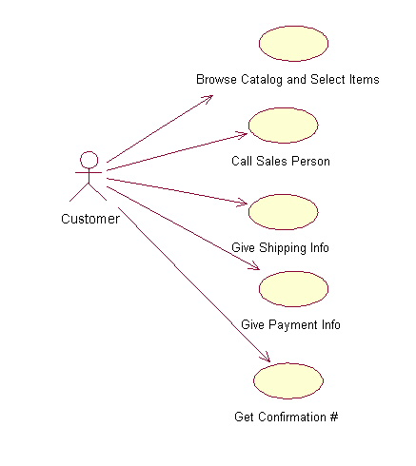

This example shows the customer as a actor because the customer is using the ordering system.  The diagram takes the simple steps listed above and shows them as actions the customer might perform.  The salesperson could also be included in this use case diagram because the salesperson is also interacting with the ordering system.

From this simple diagram the requirements of the ordering system can easily be derived.  The system will need to be able to perform actions for all of the use cases listed.  As the project progresses other use cases might appear.  The customer might have a need to add an item to an order that has already been placed.  This diagram can easily be expanded until a complete description of the ordering system is derived capturing all of the requirements that the system will need to perform.

**USE CASE DIAGRAMS**





